UNITED STATES DISTRICT COURT
WESTERN DISTRICT OF PENNSYLVANIA
BLAIR DOUGLASS, on behalf of himself and all similarly situated individuals,  Plaintiff,  v.  MONDELĒZ GLOBAL LLC,  Defendant. | Civil Action No.

NATIONWIDE CLASS ACTION COMPLAINT

Plaintiff Blair Douglass (“Douglass” or “Plaintiff”), on behalf of himself and all others similarly situated, brings this action against Defendant Mondelēz Global LLC (“Mondelēz” or “Defendant”). Plaintiff makes the following allegations pursuant to the investigation of counsel and based upon information and belief, except as to the allegations specifically pertaining to Plaintiff, which are based on personal knowledge.
NATURE AND SUMMARY OF THE ACTION
- This action arises from Defendant’s failure to make its digital properties accessible to blind individuals, which violates the effective communication and equal access requirements of Title III of the Americans with Disabilities Act (“ADA”), 42 U.S.C. §§ 12181-12189. These provisions were enacted “to provide a clear and comprehensive national mandate for the elimination of discrimination against individuals with disabilities” by “assur[ing] equality of opportunity, full participation, independent living, and economic self-sufficiency.”
- The injunctive relief that Douglass seeks will inure to the benefit of an estimated 2.3 percent of the United States population who reports having a visual disability, and to Defendant, who will extend its market reach to this population.
- For this significant portion of Americans, accessing websites, mobile applications, and other information has become a necessity, not a convenience.
- The growth of usage is rivaled only by the myriad ways in which users can harness the capabilities of the internet for the betterment of their lives through education, employment, entertainment, commerce, and countless other pursuits.
- The U.S. Chamber of Commerce has documented consumers’ increasing reliance on the internet to shop online:
The average consumer spends more than $1,700 per year on online shopping, a number that’s continuing to rise. The convenience, affordability and ability to compare prices with ease has led more and more customers to visit e-commerce sites before heading to a brick-and-mortar location.
New research by Leanplum found that 95% of consumers will buy at least half of their gifts online. Shoppers, especially millennials and Gen Zers, favor the convenience and the great offers and discounts associated more with shopping online than visiting a brick-and-mortar location. It’s these groups that are driving e-commerce retailers to be strategic with their website design. The Leanplum survey found that 80% of respondents shop on their mobile devices.
- Even the Supreme Court has acknowledged the phrase, “‘There’s an app for that’ has become part of the 21st-century American lexicon.” Apple Inc. v. Pepper, 139 S. Ct. 1514, 1518, 203 L.Ed.2d 802, 806 (2019).
- But “[a]s technology continues to evolve at a rapid pace, it is important to consider factors that can facilitate or impede technology adoption and use by people with disabilities.”
- This is especially true with respect to accessing goods and services over the internet, where people with disabilities stand to benefit immensely if online services were fully and equally accessible to them. The National Federation of the Blind explains:
In many ways, individuals with disabilities rely on Web content more so than their nondisabled peers because of inherent transportation, communication, and other barriers. A blind person does not have the same autonomy to drive to a covered entity’s office as a sighted person. A deaf or hard of hearing person does not have the same opportunity to call a covered entity’s office. A person with an intellectual disability does not have the same ability to interact independently with the staff at a covered entity’s office. The 24-hour-a-day availability of information and transactions on covered entity websites and mobile apps provides a level of independence and convenience that cannot be replicated through any other means. That is why the number of Americans who rely on the Internet has increased year after year and why entities offer information and transactions through that unique medium.
- When digital content is properly formatted, it is universally accessible to everyone. When it’s not, the content provider fails to communicate to individuals with a visual disability effectively. In turn, these individuals must expend additional time and effort to overcome communication barriers not applicable to sighted users, which may require the assistance of third parties or, in some instances, may deny outright access to the online service.
- Unfortunately, Douglass cannot fully and equally access Defendant’s Digital Platform (defined below) because Defendant’s accessibility policies and practices have made it impossible to fully and equally perceive, understand, or operate the platform’s content with screen reader auxiliary aids.
- As a result, this action for injunctive relief seeks an order requiring that Defendant (a) make its Digital Platform (defined below) accessible to Douglass and class, and (b) adopt sufficient policies and practices, the details of which are more fully described below, to ensure the platform does not become inaccessible again in the future.
JURISDICTION AND VENUE
- The claims alleged arise under Title III such that this Court’s jurisdiction is invoked pursuant to 28 U.S.C. § 1331 and 42 U.S.C. § 12188.
- Defendant attempts to, and indeed does, participate in the Commonwealth’s economic life by offering and providing services over the internet to Pennsylvania residents, including Douglass. Unlike, for example, a winery that may not be able sell and ship wine to consumers in certain states, Defendant purposefully avails itself of the benefits and advantages of operating an interactive, online business open 24-hours a day, 7-days a week, 365-days a year to Pennsylvania residents.
- To this end, each month approximately 1,592,659 individuals visit https://www.oreo.com/, which is one of the 29 websites that make up the Digital Platform. 96% of these visitors are from the United States. This means, based on U.S. Census data which indicates that 3.9% of the U.S. population resides in Pennsylvania, that approximately 59,629 individuals from Pennsylvania visit just this small fraction of the Digital Platform each month.
- These online interactions between Defendant and Pennsylvania residents involve, and indeed require, Defendant’s knowing and repeated transmission of computer files over the internet into Pennsylvania.
- Douglass was injured when he attempted to access the Digital Platform (defined below) from Pittsburgh, Pennsylvania, but encountered communication barriers that denied him full and equal access to Defendant’s online products, content, and services.
- Venue in this District is proper under 28 U.S.C. § 1391(b)(2) because this is the judicial district in which a substantial part of the acts and omissions giving rise to Douglass’s claims occurred.
PARTIES
- Douglass is a natural person over the age of 18. He resides in and is a citizen of Pittsburgh, Pennsylvania, located in Allegheny County.
- He works for an area university as a Program Administrator, managing all phases of the admission process for a highly competitive science training program, among other things. Douglass is also a licensed Pennsylvania attorney. He graduated from the University of Pittsburgh School of Law. During his enrollment at Pitt Law, Douglass completed a judicial internship in the United States District Court for the Western District of Pennsylvania.
- Douglass is and, at all times relevant hereto, has been legally blind and is therefore a member of a protected class under the ADA, 42 U.S.C. § 12102(2), and the regulations implementing the ADA set forth at 28 CFR §§ 36.101 et seq. As a result of his blindness, Douglass relies on screen access software, including JAWS 2020 from Freedom Scientific and VoiceOver with iOS, to access digital content, like an email, a website, or an app.
- Douglass has advocated for blind individuals his entire life and long before filing a lawsuit.
- The United States District Court for the Western District of Pennsylvania appointed Douglass as class representative in a class action case substantially similar to this action. Murphy v. Charles Tyrwhitt, Inc., No. 1:20-cv-00056 (Erie), 2020 U.S. Dist. LEXIS 222540, at *9, *34 (W.D. Pa. Nov. 25, 2020), report and recommendation adopted by 2021 U.S. Dist. LEXIS 144 (W.D. Pa. Jan. 4, 2021) (“Based on the above, the Court finds that Anthony Hammond Murphy and Blair Douglass [sic] will fairly and adequately represent the class as representative Plaintiffs and that their proposed class counsel will fairly and adequately protect the interests of the class and provide capable legal representation. The adequacy requirement of Rule 23(a) is satisfied.”).
- Defendant Mondelēz International, Inc. is a Virginia corporation with a principal place of business at 905 West Fulton Market, Suite 200, Chicago, IL 60607.
- Defendant sells snack foods and provides related services to consumers.
- In order to access, research, or purchase the products and services that Defendant offers, Douglass may visit Defendant’s digital properties, located at us.greenandblacks.com, www.belvitabreakfast.com, www.capaofruit.com, www.createatreat.com, www.dentyne.com, www.dirtkitchensnacks.com, www.discoverteddy.com, www.enjoylifefoods.com, www.gethalls.com, www.giveandgo.com, www.goodthins.com, www.hukitchen.com, www.kimberleysbakeshoppe.com, www.masonstbakehouse.com, www.mdlzcusthelp.com, www.milliegram.com, www.mondelezinternational.com, www.oreo.com, www.perfectsnacks.com, www.ritzcrackers.com, www.ruckusandcosnacks.com, www.snackworks.com, www.sourpatchkids.com, www.tatesbakeshop.com, www.theworthycrumb.com, www.tridentgum.com, www.triscuit.com, www.unclewallys.com, www.wheatthins.com (the “Digital Platform”).
- Defendant owns, operates, and/or controls its Digital Platform and is responsible for the policies, practices, and procedures concerning the Digital Platform’s development and maintenance.
STANDING UP FOR TITLE III OF THE ADA
- “Congress passed the ADA in 1990 to fix a serious problem—namely, the seclusion of people with disabilities resulting in explicit and implicit discrimination.” “It was called the ‘20th Century Emancipation Proclamation for all persons with disabilities.’” “Title III of the ADA contained broad language covering numerous public accommodations; both new construction and existing facilities were required by the statute to remove barriers to access. The disabled population hoped that, as a result of the ADA, their lives would no longer be shaped by limited access and the inability to choose.”
- “However, reality—a lack of compliance with the ADA and severe underenforcement of the statute—soon destroyed this hope.”
- Thirty years “after the passage of the ADA, numerous facilities are still not compliant leaving the disabled population in a second-class citizenship limbo. Title III of the ADA allows both the U.S. Attorney General and private individuals to sue, but the rate at which [ ] the Attorney General [is] bringing suit seeking compliance is extremely low. The Department of Justice’s Disability Section, tasked with ADA enforcement, is understaffed[.]”
- Thus, “private suits by necessity represent the main tool for ensuring compliance with Congress’ intent in passing the ADA,” most of which suits “are brought by a small number of private plaintiffs who view themselves as champions of the disabled.”
- DOJ supports this dynamic, recognizing that because it “cannot investigate every place of public accommodation” for ADA compliance, “[p]rivate plaintiffs play an important role in enforcing the ADA[.]”
- Courts recognize this dynamic too.
[Defendant] also points to the number of cases filed by the same plaintiff in this jurisdiction. Counsel have filed nine cases in this jurisdiction on behalf of [the plaintiff]. I am not impressed by this argument. If the ADA were enforced directly by the government, as are, for example, the fair housing laws, it is likely that government lawyers would have reached out to disabled individuals — “testers” as they are called — to find out which businesses were complying and which were not. [The named plaintiff] has functioned here as a “tester,” which is entirely appropriate.
- Consistent with the policies summarized above, Douglass assumes the role of private attorney general to ensure Defendant communicates effectively with him and other consumers who demand full and equal screen reader access to Defendant’s digital services.
SUBSTANTIVE ALLEGATIONS
- The internet is a significant source of information, services, and transactions with instant and 24/7 availability and without the need to travel to attain them.
- Individuals who are blind access the internet and mobile applications from smartphones and/or personal computers by using keyboard controls and screen access software, which vocalizes information presented visually on a computer screen or displays that information on a user-provided refreshable braille display. Such software provides the only method by which blind individuals can independently access digital information and content. When websites and applications are not designed to allow for use with screen access software, blind individuals are unable to access the information, products, and services offered through the internet.
- Screen access technology has existed for decades and widely-accepted standards exist to guide entities in making their websites and apps accessible to screen access software, including legal standards under Section 508 of the Rehabilitation Act. The U.S. Department of Health & Human Services maintains Best Practices for Accessible Content to ensure that accessibility is “considered throughout the [website] development process.” The Commonwealth of Pennsylvania has maintained an Information Technology Accessibility Policy since March 16, 2006, and a separate Accessibility Policy that recognizes “[a]ccessible websites ensure that as many people as possible can use internet-based information and services, regardless of disability or functional limitation.”
Defendant’s Inaccessible Digital Platform
- Defendant owns, operates, developed, procured, maintains and/or uses the Digital Platform for the purpose of communicating information about its products and services to consumers through computers, smartphones, and other mobile devices.
- Defendant is required to ensure that its Digital Platform communicates information about its products and services effectively to people with disabilities. Despite this obligation, Defendant fails to communicate this information effectively to individuals who are blind because the Digital Platform is not compatible with screen reader auxiliary aids.
- Specifically, Douglass attempted to access Defendant’s Digital Platform from Pittsburgh, Pennsylvania using JAWS 2020 from Freedom Scientific.
- “JAWS, Job Access With Speech, is the world’s most popular screen reader, developed for computer users whose vision loss prevents them from seeing screen content or navigating with a mouse. JAWS provides speech and Braille output for the most popular computer applications on your PC. You will be able to navigate the Internet, write a document, read an email and create presentations from your office, remote desktop, or from home.”
- In addition to using JAWS on his desktop, Douglass uses VoiceOver on his iPhone. “VoiceOver is an industry-leading screen reader that tells you exactly what’s happening on your device. VoiceOver can now describe people, objects, text, and graphs in greater detail than ever. Auditory descriptions of elements help you easily navigate your screen through a Bluetooth keyboard or simple gestures on a touchscreen or trackpad. And with unique rotor gestures that function like a dial on touchscreens and trackpads, you can make content such as websites a breeze to browse.”
- Other consumers use TalkBack to shop online from Android devices. “TalkBack is the Google screen reader included on Android devices. TalkBack gives you eyes-free control of your device.”
- Here is an example of another online store’s successful use of audio descriptions to communicate its products to screen reader users. The image on the left illustrates what shoppers perceive visually when browsing the online store with an iPhone. To the right is an image from the online store with the audio description highlighted for that image in green. Although invisible to the eye, screen access software reads this highlighted text aloud in order to describe the image to shoppers who cannot perceive content visually. In this example, when shoppers tab to the image file with a screen reader, the online store announces, “One burlap and cotton tote bag with a custom printed architectural company logo.” Blind shoppers require audio descriptions, frequently called “alternative text,” like this to access digital content fully, equally, and independently.
- Unfortunately, because of Defendant’s failure to build its Digital Platform in a manner that is compatible with screen access software, including JAWS, VoiceOver, and TalkBack, Douglass is unable to understand, and thus is denied the benefit of, much of the content and services he wishes to access from his smartphone.
- As a result of visiting the Digital Platform in May 2020, and from investigations performed on his behalf, Douglass found he could not access Defendant’s goods and services fully and equally because screen reader auxiliary aids could not access important content on the Digital Platform. For example:
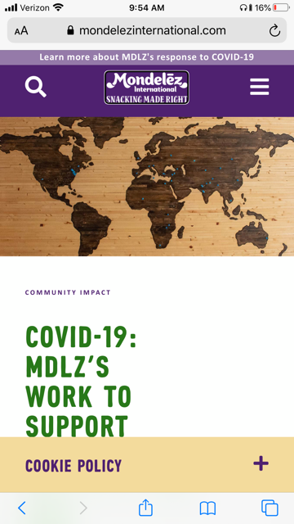

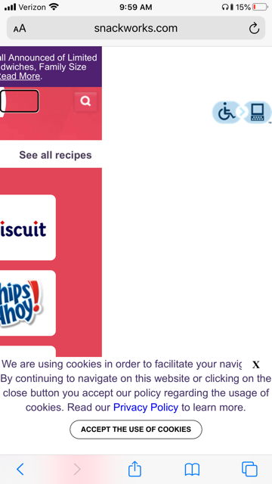
  - The Digital Platform prevents screen reader users from accessing some primary content. For example, when consumers visit the https://www.mondelezinternat ional.com/, https://www.snack works.com/, and https://wheat thins.com/ websites from a new IP address, Defendant displays a pop-up message to notify them of its cookies policy. Consumers who perceive content visually can click the button to learn more about how Defendant collects and shares their personal information with social media, advertising, and analytics partners. Unfortunately, the Digital Platform does not alert screen readers of this pop-up message. Instead, screen readers remain focused on the content of the Digital Platform’s underlying page, making the pop-up invisible to screen reader users. As a result, it is impossible for Douglass to perceive this important legal disclosure independently, depriving him of the benefits of the California Consumer Privacy Act.
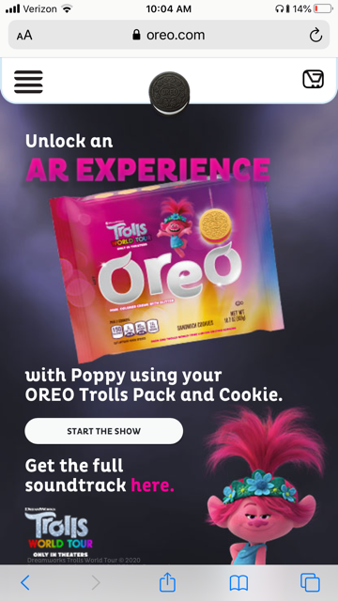
  - Links and buttons on the Digital Platform do not describe their purpose. As a result, consumers who have a visual impairment cannot determine whether they want to follow a particular link, making navigation an exercise of trial and error. For example, consumers who perceive content visually will likely recognize the shopping cart icon at https://www.oreo.com/ and understand that by clicking it, Defendant will redirect them to its online checkout platform. Unfortunately, this icon is not labeled with sufficiently descriptive alternative text. As a result, when screen readers hover over it, screen readers announce “unpronounceable,” only. Because this text is meaningless without additional context, Douglass is less likely to locate the payment platform and complete a purchase successfully.
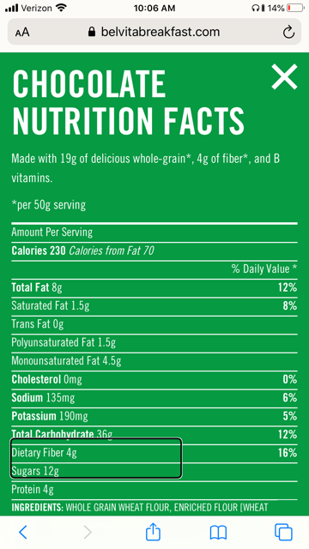
  - The Digital Platform prevents screen reader users from accessing primary content. For example, Defendant’s https://www.belvitabreakfast.com/ website allows consumers to review its products’ nutritional information. The Digital Platform displays information in a pop-up window. Consumers who perceive content visually can scroll through the pop-up to review all of the information it contains. Unfortunately, Defendant does not alert screen readers to this pop-up window. Instead, screen readers remain stuck on the unrelated elements in the website’s underlying page. This barrier makes it impossible for screen reader users, like Douglass, to tab to the nutritional information they were seeking.
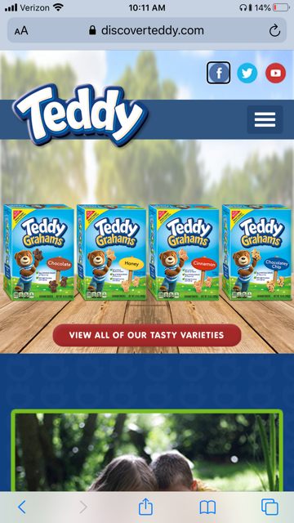
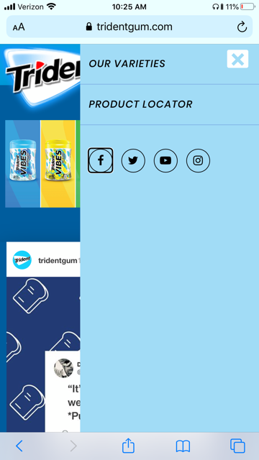
  - The Digital Platform fails to describe the purpose of links and buttons sufficiently. As a result, screen reader users have difficulty understanding what information is contained on pages and how that information is organized. When link and button labels are clear and descriptive, screen reader users can find information they seek more easily and they can understand the relationships between different pieces of content. For example, the social media links on Defendant’s https://www.discoverteddy.com/ website lack alternative text describing their purpose. Consumers who perceive content visually will likely recognize the Facebook, Twitter, and YouTube icons in the website’s header and understand that by clicking these icons, Defendant will redirect them to its different social media communities. Unfortunately, these links are not labeled with sufficiently descriptive alternative text. As a result, when screen readers hover over the Facebook icon, for example, Defendant announces, “teddy soft bakes five eight zero seven one zero five eight five four five five five seven four link navigation landmark,” only. Because this audio cue is meaningless, screen reader users, like Douglass, are likely to skip over the icon without discovering Defendant’s online community and the members in it. This access barrier contributes to the very sense of isolation and stigma the ADA was intended to eliminate. The social media icons on Defendant’s https://www.tridentgum.com/ also lack sufficiently descriptive alternative text.

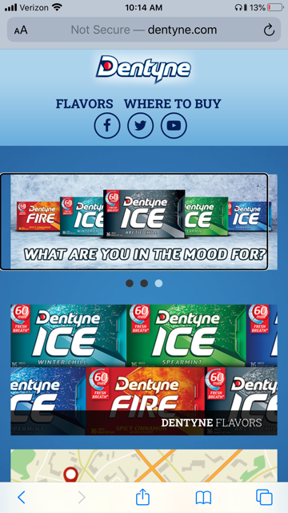
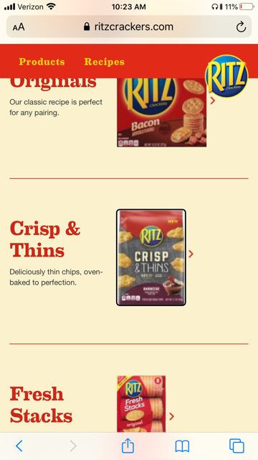
  - The Digital Platform does not provide a sufficient text equivalent for many important non-text elements. Providing text alternatives allows information to be rendered in a variety of ways by a variety of consumers. A person who cannot see a picture, logo, or icon can have a text alternative read aloud using synthesized speech. For example, consumers who perceive content visually will see various images in slideshows on the https://www.dentyne.com/, https://www.ritzcrackers.com/, and https://www.gethalls.com/ websites that lack alternative text describing their content. Because screen reader users cannot perceive the images visually, they cannot determine whether their content includes information that is material to the use of the Digital Platform. This uncertainty frustrates screen reader users’ experience and deters them from consuming Defendant’s online services.

  - Links and buttons on the Digital Platform do not describe their purpose. As a result, consumers who have a visual impairment cannot determine whether they want to follow a particular link, making navigation an exercise of trial and error. For example, consumers who perceive content visually will likely recognize the magnifying glass icon on Defendant’s https://us.greenandblacks.com/ website and understand that by clicking it, Defendant will redirect them to its online search service. Unfortunately, this icon is not labeled with sufficiently descriptive alternative text. As a result, when screen readers hover over it, they hear “unpronounceable,” only. Because this alternative text is meaningless without additional context, Douglass is less likely to locate and take advantage of this important navigational tool.

  - Similarly, consumers who perceive content visually will likely recognize the menu icon at the https://www.goodthins.com/ website and understand that by clicking it, Defendant will display a list of various sections of the website, like Products and Contact Us. Unfortunately, this icon is not labeled with sufficiently descriptive alternative text. As a result, when screen readers hover over it, screen readers announce “button,” only. Because this alternative text is meaningless without additional context, Douglass is less likely to locate and take advantage of this important navigational tool.

  - The Digital Platform does not include sufficiently descriptive labels or instructions when content requires a shopper to submit information or activate particular features. Without these instructions, screen reader users cannot fully navigate the webpages. For example, Defendant maintains an FAQ, or frequently asked question, section on its https://www.triscuit.com/ website. Consumers may access this information to learn more about various topics relating to Defendant’s products, like the GMOs they contain. Consumers who perceive content visually will notice the plus signs beside each question and understand that by clicking these icons, Defendant will display the corresponding answer to the question. Unfortunately, Defendant does not communicate this information in an alternative format which consumers who have a visual impairment may understand. As a result, Douglass is less likely to understand that an additional interaction is necessary to reveal answers to the questions he is researching.
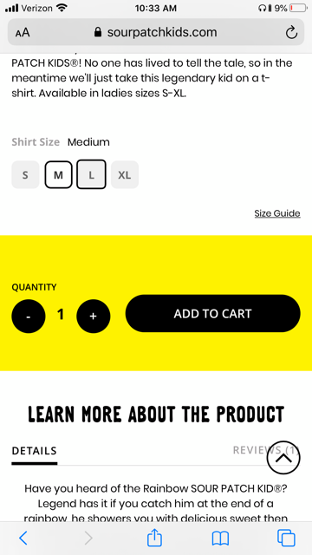
  - The Digital Platform uses visual cues as the only means of conveying information, indicating an action, prompting a response, or distinguishing a visual element. Providing information conveyed visually through another means is necessary to ensure that consumers who cannot perceive visual cues can still perceive important information in a non-visual manner. For example, the https://sourpatchkids.com/ website allows consumers to select the size of the apparel they wish to purchase. Defendant identifies the selected size visually by placing a black border around the size a shopper selects, and changing the background of the consumer’s selection from gray to white. Unfortunately, Defendant fails to include alternative text to identify this selection in a non-visual means. This makes it difficult and frustrating, if not impossible, for Douglass to verify what size apparel he selected, if any.
- Consistent with public policy encouraging the resolution of “dispute[s] informally by means of a letter[,]” see Yahoo! Inc. v. La Ligue Contre Le Racisme Et L’Antisemitisme, 433 F.3d 1199, 1208 (9th Cir. 2006), which “prelitigation solutions [are] clearly, the most expedient and cost-effective means of resolving” website accessibility claims, see Sipe v. Am. Casino & Ent. Properties, LLC, 2016 WL 1580349, *2-3 (W.D. Pa. Apr. 20, 2016), Douglass contacted Defendant about its inaccessible Digital Platform in June 2020.
- Notwithstanding this pre-suit notice, Douglass found the Digital Platform still denies him full and equal access when he returned to it in June 2022. Douglass’s experience is consistent with the investigation of his counsel, which confirms that screen reader auxiliary aids still cannot access important content on the Digital Platform using two of the most common screen readers on the market today: VoiceOver and JAWS.
VoiceOver
  - Defendant prevents screen reader users from accessing some primary content. For example, when consumers visit www.dentyne.com, www.tridentgum.com, and www.wheatthins.com from a new IP address, Defendant displays pop-up messages notifying them of its cookies policy. Consumers who perceive content visually can click the pop-ups to learn more about how Defendant collects and shares their personal information with social media, advertising, and analytics partners. Unfortunately, Defendant does not alert screen readers of these pop-up messages. Instead, screen readers remain focused on the websites’ underlying pages, making the pop-ups invisible to screen reader users. As a result, it is impossible for Plaintiff to perceive these important legal disclosures independently. Click the following links to view short videos demonstrating this access barrier: https://youtube.com/shorts/ekjFVM8G0V4?feature=share (Dentyne), https://youtube.com/shorts/TLhPU0aI498 (Trident), and https://youtube.com/shorts/-6Tu-enDaag?feature=share (Wheat Thins).
  - Similarly, when consumers visit www.enjoylifefoods.com and www.sourpatchkids.com from a new IP address, Defendant displays a pop-up messages offering them access to special promotions and other information in exchange for joining Defendant’s email lists. Unfortunately, Defendant does not alert screen readers of these pop-up messages when they appear. Instead, screen readers remain focused on the content of the websites’ underlying pages, making the pop-ups invisible to screen reader users. As a result, it is impossible for Plaintiff to perceive these promotions independently, the effect of which would require him to pay more on his orders than consumers who do not use screen readers to shop online. Click the following links to view short videos demonstrating this access barrier: https://youtube.com/shorts/Vh2Qxyl3vP0 (Enjoy Life Foods) and https://youtube.com/shorts/2i49JNDLgko (Sour Patch Kids).
  - Defendant does not provide a text equivalent for non-text elements. Providing text alternatives allows information to be rendered in a variety of ways by a variety of users. A person who cannot see a picture, logo, or icon can have a text alternative read aloud using synthesized speech. For example, www.capaofruit.com and www.hukitchen.com provide a five-star rating for many products that Defendant sells. Consumers who perceive content visually can see whether a particular product has one, two, three, four, or five stars, and base their purchasing decisions on this information. Unfortunately, Defendant fails to provide sufficiently descriptive alternative text for this important rating information. As a result, Plaintiff must make his purchasing decisions without the benefit of knowing whether the products he’s researching are well received by other consumers. Click the following links to view short videos demonstrating this access barrier: https://youtube.com/shorts/Q2KuR_cBc84 (Capao Fruit) and https://youtube.com/shorts/6IVH8u_76J4 (Hu Kitchen).
  - Links and buttons on the Digital Platform do not describe their purpose. As a result, consumers who have a visual impairment cannot determine whether they want to follow a particular link, making navigation an exercise of trial and error. For example, consumers who perceive content visually will likely recognize the menu icons at www.masonstbakehouse.com, www.ritzcrackers.com, and www.snackworks.com, which consumers may click to view and navigate to various sections of the websites. Unfortunately, these icons are not labeled with sufficiently descriptive alternative text. As a result, Plaintiff is unlikely (or unable) to locate the menus independently, making it less likely he uses these important navigational tools while browsing the websites. Click the following links to view short videos demonstrating this access barrier: https://youtube.com/shorts/i60FTl3unnw (Mason St. Bake House), https://youtube.com/shorts/UCuDtpSWWTk (Ritz Crackers), and https://youtube.com/shorts/omomPMqF5KI (Snack Works).
  - Defendant uses visual cues to convey content and other information. Unfortunately, screen readers cannot interpret these cues and communicate the information they represent to individuals with visual disabilities. For example, consumers who perceive content visually will notice that many products available for purchase at www.perfectsnacks.com include two prices. One price—a higher price—appears in strikethrough font. The other—a lower price—does not. Consumers who perceive content visually will understand that the price appearing in strikethrough font is the “old” or “original” price, while the price appearing in regular font is the “new” or “sale” price. Unfortunately, screen readers cannot identify the meanings of these two fonts so that users can make an informed decision. Instead, Defendant announces two prices for the same product, making it difficult for consumers to determine with certainty what they signify, like different quantities, conditions, sizes, or in this case, sales. This unnecessary confusion frustrates Plaintiff’s ability to make informed purchasing decisions and increases the odds he will abandon the purchase process without making a selection at all. Click the following link to view a short video demonstrating this access barrier: https://youtube.com/shorts/rRh3NkGcofs (Perfect Snacks).
  - Defendant uses visual cues as the only means of conveying information, indicating an action, prompting a response, or distinguishing a visual element. Providing information conveyed visually through an audio means is necessary to ensure that consumers who cannot see can still perceive this information. For example, Defendant places a red slash atop the sizes in which a particular product is unavailable at www.oreo.com. Consumers who perceive content visually will see this visual cue and infer that the product they’re researching is unavailable in the corresponding size. Unfortunately, Defendant fails to include sufficiently descriptive alternative text to also identify which sizes are unavailable, making it impossible for Plaintiff to discover which sizes are out-of-stock. Click the following link to view a short video demonstrating this access barrier: https://youtube.com/shorts/e4ZQ9X-mFDI (Oreo).
  - Defendant’s www.tatesbakeshop.com website features a menu button that consumers may click to view various sections of the website. Defendant displays this information in a pop-up window that consumers may use to navigate to other webpages. Unfortunately, Defendant does not alert screen readers when this pop-up window appears. Instead, screen readers remain focused on the content of the website’s underlying page, making the menu invisible to screen reader users. As a result, it is impossible for Plaintiff to navigate the website with this important navigational tool. Click the following link to view a short video demonstrating this access barrier: https://youtube.com/shorts/GPqLIAjE7ns (Tate’s Bake Shop).
JAWS
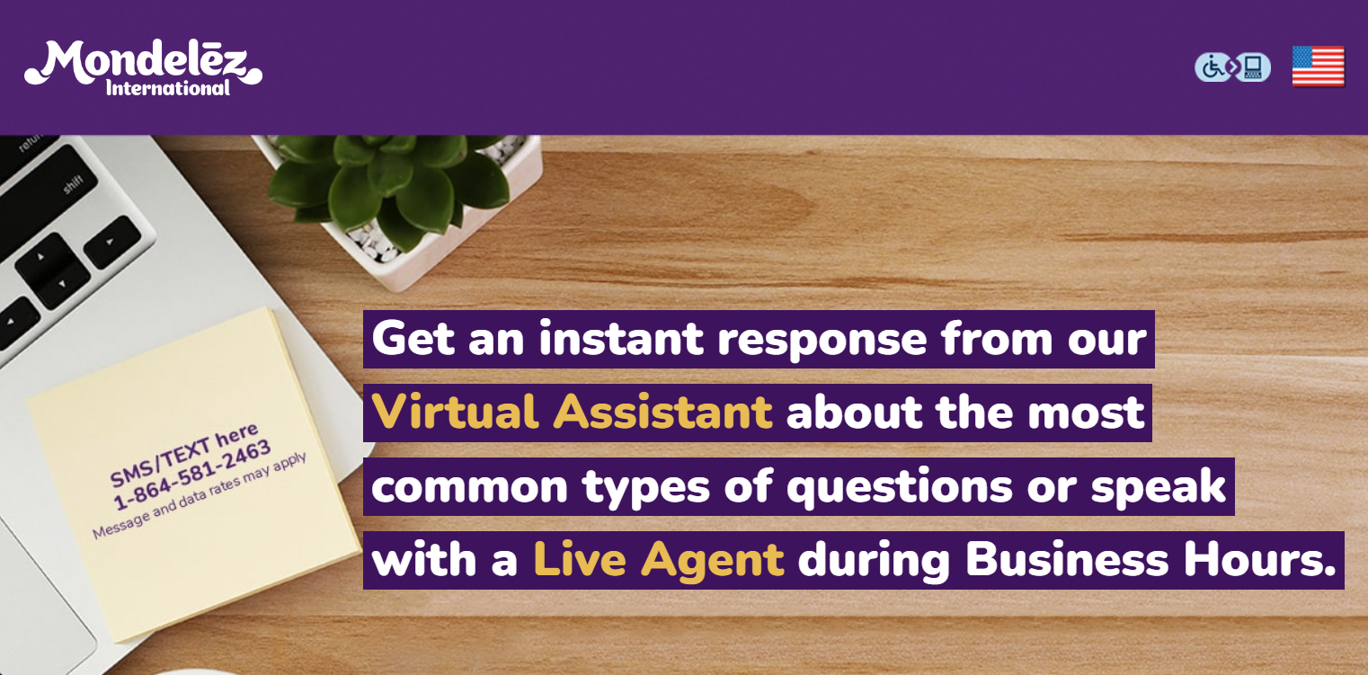
- Defendant does not provide a sufficient text equivalent for many important non-text elements. Providing text alternatives allows information to be rendered in a variety of ways by a variety of consumers. A person who cannot see a picture, logo, or icon can have a text alternative read aloud using synthesized speech. For example, screen reader users will encounter an image at www.mdlzcusthelp.com that includes a telephone number that consumers may use to text questions during business hours. Unfortunately, this image lacks alternative text to notify bind consumers of this important resource. As a result, it is unlikely (if not impossible) for screen reader users, including Plaintiff, to contact Defendant for help via text.
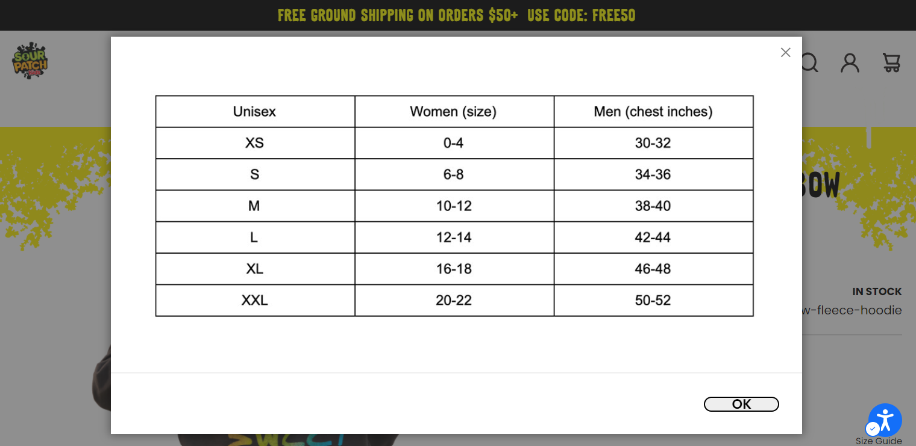
- Defendant relies on image files to convey other important content as well. For example, Defendant displays an image file to describe the measurements of apparel it sells at www.sourpatchkids.com. Size guides are particularly important to consumers who shop online because they lack the opportunity to try on products, like the apparel that Defendant sells, before making a purchase. Unfortunately, this image lacks alternative text conveying the sizing information to consumers who do not perceive content visually. As a result, screen reader users, including Plaintiff, are unable to access the sizing information they require to confidently purchase apparel that will fit, making it more likely they abandon the online shopping experience before completing a purchase.
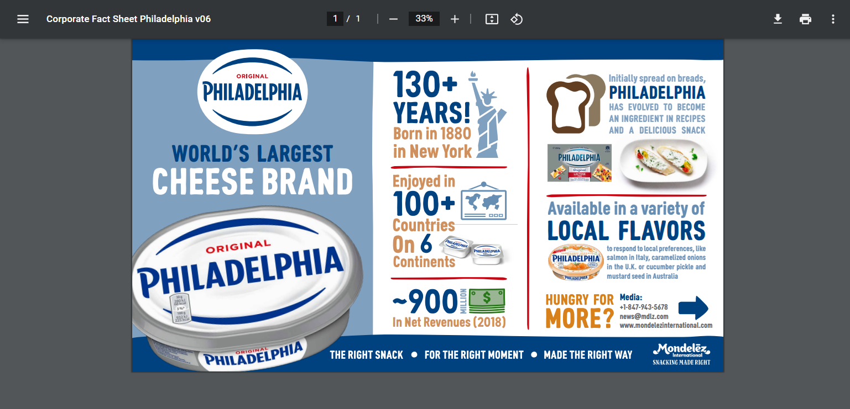
- Defendant prevents screen reader users from accessing PDF content at www.mondelezinternational.com. PDF is a file format for representing documents in a manner independent of the application software, hardware, and operating system used to create them, as well as of the output device on which they are to be displayed or printed. PDF files specify the appearance of pages in a document in a reliable, device-independent manner. PDF includes several features in support of accessibility of documents to users with disabilities. The core of this support lies in the ability to determine the logical order of content in a PDF document, independently of the content’s appearance or layout, through logical structure and Tagged PDF. Applications can extract the content of a document for presentation to users with disabilities by traversing the structure hierarchy and presenting the contents of each node. For this reason, producers of PDF files must ensure that all information in a document is reachable by means of the structure hierarchy. Unfortunately, Defendant has not made the PDFs on its Digital Platform accessible consistent with these principles. As a result, screen reader users, including Plaintiff, cannot access the content these PDFs include.
Plaintiff’s Injury
- As a result of the access barriers described above, and others, Defendant fails to communicate information about its products and services to Douglass effectively, which in turn denies Douglass full and equal access to Defendant’s Digital Platform and deters him from returning to the store in the future.
- Still, Douglass intends to attempt to access the Digital Platform within the next six months to research the products, services, and content Defendant offers and to test the Digital Platform to determine whether it is fully and equally accessible to blind consumers.
- If the Digital Platform were accessible (i.e. if Defendant removed the access barriers and implemented the practices described herein), Douglass could fully, equally, and independently access Defendant’s online store.
Defendant’s Digital Platform Must Comply with the ADA
- The ADA “as a whole is intended ‘to provide a clear and comprehensive national mandate for the elimination of discrimination against individuals with disabilities.’”
- Title III advances that goal by providing that “[n]o individual shall be discriminated against on the basis of disability in the full and equal enjoyment of the products, services, facilities, privileges, advantages, or accommodations of any place of public accommodation by any person who owns, leases (or leases to), or operates a place of public accommodation.”
- DOJ regulations require that a public accommodation “furnish appropriate auxiliary aids and services where necessary to ensure effective communication with individuals with disabilities.”
- DOJ defines “auxiliary aids and services” to include “accessible electronic and information technology” or “other effective methods of making visually delivered materials available to individuals who are blind or have low vision.”
- Therefore, the ADA mandates that places of public accommodation provide auxiliary aids and services to make visual materials available to individuals who are blind.
- Defendant is a place of public accommodation under the ADA because it is a “sales or rental establishment” and/or “other service establishment.”
- The Digital Platform is a service, facility, advantage, or accommodation of Defendant.
- As a service, facility, advantage, or accommodation of Defendant, Defendant must ensure blind patrons have full and equal access to the Digital Platform.
- Indeed, the ADA expressly provides that a place of public accommodation engages in unlawful discrimination if it fails to “take such steps as may be necessary to ensure that no individual with a disability is excluded, denied services, segregated or otherwise treated differently than other individuals because of the absence of auxiliary aids and services.”
Defendant Received Fair Notice of its ADA Obligations
- Defendant and other covered entities have known since at least 1996 that public accommodations must offer individuals with disabilities an equal opportunity to access digital marketplaces.
- Since its enactment in 1990, the ADA has clearly stated that covered entities must provide “full and equal enjoyment of the[ir] goods, services, facilities, privileges, advantages, or accommodations” to people with disabilities, and must “ensure that no individual with a disability is excluded, denied services, segregated or otherwise treated differently than other individuals because of the absence of auxiliary aids and services.”
- The United States Department of Justice (“DOJ”) confirmed Title III applies to websites of public accommodations in a 1996 letter from Assistant Attorney General Deval Patrick responding to an inquiry by Senator Tom Harkin regarding the accessibility of websites to blind individuals.
- Since then, DOJ has “repeatedly affirmed the application of [T]itle III to Web sites of public accommodations.”
- In 2000, DOJ argued to the Fifth Circuit that a business providing services solely over the internet is subject to the ADA’s prohibitions on discrimination on the basis of disability.
- In 2002, DOJ argued to the Eleventh Circuit that there need not be a nexus between a challenged activity and a private entity’s “brick-and-mortar” facility to obtain coverage under Title III. DOJ argued that Title III applies to any activity or service offered by a public accommodation, on or off the premises.
- In 2014, DOJ entered into a settlement agreement with America’s then-leading internet grocer to remedy allegations that its website, www.peapod.com, is inaccessible to some individuals with disabilities, in violation of the ADA. DOJ’s enforcement action against this online-only business affirms the ADA covers public accommodations that do not operate brick-and-mortar facilities open to the public.
- In a September 25, 2018 letter to U.S. House of Representative Ted Budd, U.S. Department of Justice Assistant Attorney General Stephen E. Boyd confirmed that public accommodations must make the websites they own, operate, or control equally accessible to individuals with disabilities. Assistant Attorney General Boyd’s letter provides:
The Department [of Justice] first articulated its interpretation that the ADA applies to public accommodations’ websites over 20 years ago. This interpretation is consistent with the ADA’s title III requirement that the goods, services, privileges, or activities provided by places of public accommodation be equally accessible to people with disabilities.
- In 2019, the United States Supreme Court declined to review a Ninth Circuit decision holding that (1) Title III of the Americans with Disabilities Act, 42 U.S.C. § 12101 et seq. (“Title III”) covers websites and mobile applications and (2) the imposition of liability on businesses for not having an accessible website and mobile application does not violate the due process rights of public accommodations.
- On March 18, 2022, DOJ published guidance on digital accessibility and confirmed it “has consistently taken the position that the ADA’s requirements apply to all the services, programs, or activities of state and local governments, including those offered on the web.”
- Thus, since at least since 1996, Defendant has been on notice that its online offerings must effectively communicate with disabled consumers and facilitate “full and equal enjoyment” of the products and services it offers.
CLASS ALLEGATIONS
- Douglass brings this class action pursuant to Fed. R. Civ. P. 23(a) and 23(b)(2) on behalf of himself and the following nationwide class: all blind or visually disabled individuals who use screen reader auxiliary aids to navigate digital content and who have accessed, attempted to access, or been deterred from attempting to access, or who may access, attempt to access, or be deterred from accessing the Digital Platform from the United States.
- Numerosity: The class described above is so numerous that joinder of all individual members in one action would be impracticable. The disposition of the individual claims of the respective class members through this class action will benefit both the parties and this Court, and will facilitate judicial economy.
- Typicality: Plaintiff’s claims are typical of the claims of the members of the class. The claims of Plaintiff and members of the class are based on the same legal theories and arise from the same unlawful conduct.
- Common Questions of Fact and Law: There is a well-defined community of interest and common questions of fact and law affecting members of the class in that they all have been, are being, and/or will be denied their civil rights to full and equal access, and use and enjoyment of Defendant’s Digital Platform and/or services due to Defendant’s failure to make the Digital Platform fully accessible and independently usable as described herein.
- Adequacy of Representation: Plaintiff is an adequate representative of the class because his interests do not conflict with the interests of the members of the class. Plaintiff will fairly, adequately, and vigorously represent and protect the interests of the members of the class, and he has no interests antagonistic to the members of the class. Plaintiff has retained counsel who are competent and experienced in the prosecution of class action litigation, generally, and who possess specific expertise in the context of ADA litigation.
- Class certification is appropriate under Fed. R. Civ. P. 23(b)(2) because Defendant has acted or refused to act on grounds generally applicable to the class, making appropriate both declaratory and injunctive relief with respect to Plaintiffs and the class as a whole.
FIRST CLAIM FOR RELIEF
Title III of the ADA, 42 U.S.C. § 12181 et seq.
- The assertions contained in the previous paragraphs are incorporated by reference.
- Title III of the ADA guarantees that individuals with disabilities shall have full and equal enjoyment of the products, services, facilities, privileges, advantages, or accommodations of any place of public accommodation.
- Defendant is bound by the regulations implementing Title III of the ADA, which require that places of public accommodation ensure effective communication to individuals with disabilities.
- Douglass is legally blind and therefore an individual with a disability under the ADA.
- Defendant is a place of public accommodation under the ADA because it is a “sales or rental establishment” and/or “other service establishment.”
- Defendant owns, operates, or maintains the Digital Platform.
- The Digital Platform is a service, facility, privilege, advantage, or accommodation of Defendant.
- The Digital Platform contains communication barriers that prevent blind persons, including Douglass, from accessing it with screen reader auxiliary aids fully and equally.
- Because of these communication barriers, Defendant denies Douglass full and equal enjoyment of the information, products, services, facilities, privileges, advantages, or accommodations that it makes available to the sighted public through the Digital Platform.
- These access barriers now deter Douglass from attempting to use the Digital Platform.
- Douglass intends to attempt to access the Digital Platform within the next six months.
- Defendant’s discrimination is ongoing.
PRAYER FOR RELIEF
WHEREFORE, Douglass requests judgment as follows:
- An order certifying the proposed Class, appointing Douglass as representative of the proposed Class, and appointing undersigned counsel as counsel for the proposed Class;
- A Declaratory Judgment that at the commencement of this action Defendant was in violation of the specific requirements of Title III of the ADA described above, and the relevant implementing regulations of the ADA, in that Defendant took no action that was reasonably calculated to ensure Defendant communicated the digital content of its Digital Platform to individuals with disabilities effectively such that Douglass could fully, equally, and independently access Defendant’s products and services;
- A permanent injunction pursuant to 42 U.S.C. § 12188(a)(2) and 28 CFR § 36.504(a) which directs Defendant to take all steps necessary to communicate the content of its Digital Platform to screen reader users effectively such that Defendant’s online products and services are fully, equally, and independently accessible to individuals with visual disabilities, and which further directs that the Court shall retain jurisdiction for a period to be determined to ensure that Defendant has adopted and is following an institutional policy that will in fact cause it to remain fully in compliance with the law—the specific injunctive relief requested by Plaintiff is described more fully below:
  - Within 90-days of the Court’s Order, Defendant shall complete an accessibility audit of its Digital Platform that will examine the accessibility and usability of the Digital Platform by consumers who are blind.
  - Within 180-days of the Court’s Order, Defendant shall develop a corrective action strategy (“Strategy”) based on the audit findings. In addition to the deadlines outlined below, the Strategy shall include dates by which corrective action shall be completed.
  - Within 210-days of the Court’s Order, Defendant shall disseminate the Strategy among its executive-level managers, employees, and contractors, if any, involved in digital development and post it on the Digital Platform.
  - Within 90-days of the Court’s Order, Defendant shall develop a Digital Accessibility Policy Statement that demonstrates its commitment to digital accessibility to blind and other print disabled consumers, as required by the Americans with Disabilities Act. This Policy Statement shall be posted in the header of each homepage on the Digital Platform within 120-days of the Court’s Order, and shall disclose that an audit is taking or has taken place and that a Strategy will be disseminated and posted on the Digital Platform within 180-days of the Court’s Order.
  - Within 240-days of the Court’s Order, Defendant shall develop procedures to implement its Digital Accessibility Policy across the entire Digital Platform. Defendant shall disseminate its Policy and procedures to its executive-level managers, employees, and contractors, if any, involved in digital development.
  - Within 12-months of the Court’s Order, Defendant shall conduct training, instruction and support to ensure that all executive-level managers and employees involved in digital development are aware of and understand the Digital Accessibility Policy, including proper procedures, tools, and techniques to implement the Digital Accessibility Policy effectively and consistently.
  - Within 12-months of the Court’s Order, Defendant shall hire or designate a staff person with responsibility and commensurate authority, to monitor the Digital Accessibility Policy and procedures.
  - Within 12-months of the Court’s Order, Defendant shall develop and institute procedures that require third-party content and plug-ins built into the Digital Platform to provide blind consumers the same programs, benefits and services that they do to individuals without disabilities, except that when it is technically unfeasible to do so. Defendant shall effectuate these obligations by, among other things, implementing as part of its Request for Proposal process language that bidders meet the accessibility standards set forth in WCAG 2.1 Level AA for web-based technology and the Americans with Disabilities Act; requiring or encouraging, at Defendant’s discretion, as part of any contract with its vendors, provisions in which the vendor warrants that any technology provided complies with these standards and any applicable current federal disability law.
  - Within 18-months, all pages hosted on the Digital Platform that have been published shall be Accessible to blind users. “Accessible” means fully and equally accessible to and independently usable by blind individuals so that blind consumers are able to acquire the same information, engage in the same interactions, and enjoy the same services as sighted consumers, with substantially equivalent ease of use.
  - Defendant shall not release for public viewing or use a substantial addition, update, or change to the Digital Platform until it has determined through automated and user testing that those proposed additions, updates, or changes are Accessible.
  - Defendant shall conduct (a) an automated scan monthly and (b) end-user testing quarterly thereafter to ascertain whether any new posted content is accessible. Defendant shall notify all employees and contractors, if any, involved in digital development if corrections to the Digital Platform are needed and of reasonable timelines for corrections to be made. Defendant shall note if corrective action has been taken during the next monthly scan and quarterly end-user test.
  - Following the date of the Court’s Order, for each new, renewed, or renegotiated contract with a vendor of Third-Party Content, Defendant shall seek a commitment from the vendor to provide content in a format that is Accessible.
  - Defendant shall provide Plaintiff, through his counsel, with a report on the first and second anniversaries of the Court’s Order which summarize the progress Defendant is making in meeting its obligations. Additional communication will occur before and after each anniversary to address any possible delays or other obstacles encountered with the implementation of the Digital Accessibility Policy.
- Payment of actual, statutory, nominal, and other damages, as the Court deems proper;
- Payment of costs of suit;
- Payment of reasonable attorneys’ fees, pursuant to 42 U.S.C. § 12205 and 28 CFR § 36.505, including costs of monitoring Defendant’s compliance with the judgment;
- Whatever other relief the Court deems just, equitable and appropriate; and
- An Order retaining jurisdiction over this case until Defendant has complied with the Court’s Orders.
Dated: June 14, 2022 | /s/ Kevin W. Tucker
 | Kevin W. Tucker (He/Him) (PA 312144)
Kevin J. Abramowicz (He/Him) (PA 320659)
Chandler Steiger (She/Her) (PA 328891)
Stephanie Moore (She/Her) (PA 329447)
 | EAST END TRIAL GROUP LLC
 | 6901 Lynn Way, Suite 215
 | Pittsburgh, PA 15208
Tel. (412) 877-5220
Fax. (412) 626-7101
ktucker@eastendtrialgroup.com
kabramowicz@eastendtrialgroup.com
csteiger@eastendtrialgroup.com
smoore@eastendtrialgroup.com

For semantic convenience, Douglass uses the word “blind” to describe individuals who, as a result of a visual impairment, have substantially limited eyesight. This includes individuals who have no vision at all as well as people who have low vision.
42 U.S.C. § 12101(b)(1).
42 U.S.C. § 12101(a)(7).
Erickson, W., Lee, C., von Schrader, S., Disability Statistics from the American Community Survey (ACS), Cornell University Yang-Tan Institute (YTI), www.disabilitystatistics.org (last accessed June 14, 2022).
Sharron Rush, The Business Case for Digital Accessibility, W3C Web Accessibility Initiative (Nov. 9, 2018), https://www.w3.org/WAI/business-case/ (last accessed June 14, 2022) (“The global market of people with disabilities is over 1 billion people with a spending power of more than $6 trillion. Accessibility often improves the online experience for all users.”).
Emily Heaslip, A Guide to Building an Online Store, U.S. Chamber of Commerce (Sept. 20, 2019), https://www.uschamber.com/co/start/startup/how-to-build-online-stores (last accessed June 14, 2022).
Emily Heaslip, 5 Ways to Optimize Your E-Commerce Site for Mobile Shopping, U.S. Chamber of Commerce (Jan. 6, 2020), https://www.uschamber.com/co/run/technology/building-mobile-friendly-ecommerce-websites (last accessed June 14, 2022). “According to one report, e-commerce is growing 23% each year[.]” Emily Heaslip, The Complete Guide to Selling Online, U.S. Chamber of Commerce (Jan. 28, 2020), https://www.uschamber.com/co/run/technology/small-business-ecommerce-guide (last accessed June 14, 2022).
National Disability Policy: A Progress Report, Nat’l Council on Disability (Oct. 7, 2016), https://ncd.gov/sites/default/files/NCD_ProgressReport_ES_508.pdf (last accessed June 14, 2022).
Comment from disability rights organizations to DOJ Supplemental Advance Notice of Proposed Rulemaking “Nondiscrimination on the Basis of Disability; Accessibility of Web Information and Services of State and Local Government Entities,” C RT Docket No 128, RIN 119 -AA65, Answer 57 (October 7, 2016) (citations omitted).
These factors often lead disabled individuals to abandon the process of purchasing items online after they begin. Kasey Wehrum, Your Website is Scaring Customers Away. 5 Easy Ways to Fix It., Inc. Mag. (Jan. 2014), https://www.inc.com/magazine/201312/kasey-wehrum/how-to-get-online-customers-to-complete-purchase.html (last accessed June 14, 2022) (documenting the most common causes of shopping cart abandonment, including: “Your Checkout button is hard to find[,]” “Shoppers question the safety of their personal info[,]” and “Getting through the checkout process takes multiple clicks.”).
See Gniewkowski v. Lettuce Entertain You Enters., No. 2:16-cv-1898-AJS, Order, ECF 123 (W.D. Pa Apr. 25, 2017), clarified by Order of Court, ECF 169 (W.D. Pa. June 22, 2017) (Judge Schwab) (citing Zippo Mfg. Co. v. Zippo Dot Com, Inc., 952 F. Supp. 1119 (W.D. Pa. 1997) (exercising specific personal jurisdiction over forum plaintiff’s website accessibility claims against out-of-forum hotel operator)); Law School Admission Council, Inc. v. Tatro, 153 F. Supp. 3d 714, 720-21 (E.D. Pa. 2015) (exercising personal jurisdiction over out-of-forum website operator); Access Now Inc. v. Otter Products, LLC, 280 F. Supp. 3d 287 (D. Mass. 2017) (exercising personal jurisdiction over forum plaintiff’s website accessibility claims against out-of-forum website operator); Access Now, Inc. v. Sportswear, Inc., 298 F. Supp. 3d 296 (D. Mass. 2018) (same).
Crunchbase, Oreo, available at https://www.crunchbase.com/organization/oreo/technology (last visited June 14, 2022).
Id.
Compare United States Census Bureau, QuickFacts Pennsylvania, available at https://www.census.gov/quickfacts/fact/table/PA# (last visited June 14, 2022) with United States Census Bureau, QuickFacts United States, available at https://www.census.gov/quickfacts/fact/table/US/PST045221 (last visited June 14, 2022).
Blair Douglass, LinkedIn, https://www.linkedin.com/in/blair-douglass-a0700871 (last accessed June 14, 2022).
Treshea N. Wade, Blindness doesn’t keep teen from success, Trib Total Media (May 30, 2005), https://archive.triblive.com/news/blindness-doesnt-keep-teen-from-success/ (last accessed June 14, 2022) (“I am not striving necessarily for perfection, but I just want to do well[.] …Sure I have a disability. But it’s a disability that anyone can readily overcome with a lot of hard work.”); Zak Koeske, Pitt student aims to rise above stereotype, Pittsburgh Post-Gazette (July 23, 2009), https://www.post-gazette.com/local/south/2009/07/23/Pitt-student-aims-to-rise-above-stereotype/stories/200907230364 (last accessed June 14, 2022) (“Blindness can't hold you back from doing anything you want to do[.] …Blindness is simply a physical condition. You have to make a few adaptations, but those aren't big enough to affect your ability to do a job competently. …There are always going to be some people who doubt your ability. ... I have no trouble trying to prove them wrong.”).
Kelly Johnson, Testers Standing up for the Title III of the ADA, 59 Cas. W. Res. L. Rev. 683, 684 (2009), http://scholarlycommons.law.case.edu/caselrev/vol59/iss3/6 (last accessed June 14, 2022) (citing H.R. REP. No. 101-485, pt. 2, at 28-29 (1990)).
Id. (quoting D. Russell Hymas & Brett R. Parkinson, Comment, Architectural Barriers Under the ADA: An Answer to the Judiciary’s Struggle with Technical Non-Compliance, 39 Cal. W. L. Rev. 349, 350 (2003), https://scholarlycommons.law.cwsl.edu/cgi/viewcontent.cgi?article=1166&context=cwlr (last accessed June 14, 2022)); see also 136 Cong. Rec. 17,369 (1990) (statement of Sen. Tom Harkin) (discussing how facilities have failed to comply with the ADA by not removing barriers that impede access).
Johnson, supra note 14 (citing Elizabeth Keadle Markey, Note, The ADA’s Last Stand?: Standing and the Americans with Disabilities Act, 71 Fordham L. Rev. 185 (2002), https://ir.lawnet.fordham.edu/flr/vol71/iss1/4 (last accessed June 14, 2022) (arguing for a more lenient standard for standing under the ADA)).
Johnson, supra note 14 (citing Samuel R. Bagenstos, The Perversity of Limited Civil Rights Remedies: The Case of “Abusive” ADA Litigation, 54 UCLA L. Rev. 1, 3 (2006), https://www.uclalawreview.org/the-perversity-of-limited-civil-rights-remedies-the-case-of-abusive-ada-litigation/ (last accessed June 14, 2022) (discussing the need for private enforcement in Title III of the ADA and the fact that the limitations courts are placing on ADA plaintiffs are causing abusive litigation)).
42 U.S.C. § 12188(b).
42 U.S.C. § 12188(a).
Johnson, supra note 14.
Betancourt v. Ingram Park Mall, 735 F. Supp. 2d 587, 596 (W.D. Tex. 2010).
Id. (quoting Molski v. Evergreen Dynasty Corp., 500 F.3d 1047, 1062 (9th Cir. 2007)); D’Lil v. Best Western Encina Lodge & Suites, 538 F.3d 1031, 1040 (9th Cir. 2008) (same).
Statement of Interest of the United States of America, ERC v. Abercrombie & Fitch Co., No. 1:09-cv-03157 (D. Md.), ECF No. 38, at *1 (July 6, 2010); See also Hensley v. Eckerhart, 461 U.S. 424, 445 (1983) (“All of these civil rights laws depend heavily upon private enforcement, and fee awards have proved an essential remedy if private citizens are to have a meaningful opportunity to vindicate the important Congressional policies which these laws contain.”).
Norkunas v. HPT Cambridge, LLC, 969 F. Supp. 2d 184, 194 (D. Mass. 2013) (Young, J.) (quoting Iverson v. Braintree Prop. Assocs., L.P., No. 04-cv-12079-NG, 2008 WL 552652, at *3 n.5 (D. Mass. Feb. 26, 2008) (Gertner, J.)); see also Murphy v. Bob Cochran Motors, Inc., No. 1:19-cv-00239, 2020 U.S. Dist. LEXIS 139887, at *15-16 (W.D. Pa. Aug. 4, 2020), adopted by Murphy v. Bob Cochran Motors, Inc., 2020 U.S. Dist. LEXIS 177593 (W.D. Pa., Sept. 28, 2020) (upholding tester standing in a substantially identical ADA website accessibility case).
Annemarie Cooke, A History of Accessibility at IBM, American Found. for the Blind (Mar. 2004), https://www.afb.org/aw/5/2/14760 (last accessed June 14, 2022) (Jim Thatcher created the first screen reader at IBM in 1986).
See Accessibility Basics, U.S. Dep’t of Health & Human Servs., usability.gov, https://www.usability.gov/what-and-why/accessibility.html (last accessed June 14, 2022).
Information Technology Policy: Information Technology Accessibility Policy, Pa. Office of Admin. (Mar. 16, 2006), https://www.oa.pa.gov/Policies/Documents/itp_acc001.pdf (last accessed June 14, 2022).
Accessibility Policy, Commonwealth of Pa., https://www.pa.gov/accessibility-policy/ (last accessed June 14, 2022).
JAWS®, Freedom Scientific, https://www.freedomscientific.com/products/software/jaws/ (last accessed June 14, 2022).
See Accessibility, Apple, https://www.apple.com/accessibility/vision/ (last accessed June 14, 2022).
See Google, Android Accessibility Help: TalkBack: Get Started on Android with TalkBack, https://support.google.com/accessibility/android/answer/6283677?hl=en (last visited July 20, 2020).
See Custom Ink, Homepage, https://www.customink.com/ (last accessed Mar. 28, 2019).
Wehrum, supra note 10.
Norkunas v. HPT Cambridge, LLC, 969 F. Supp. 2d 184, 194 (D. Mass. 2013) (Young, J.) (quoting Iverson v. Braintree Prop. Assocs., L.P., No. 04-cv-12079-NG, 2008 WL 552652, at *3 n.5 (D. Mass. Feb. 26, 2008) (Gertner, J.)).
Olmstead v. L.C. ex rel. Zimring, 527 U.S. 581, 589 (1999) (quoting 42 U.S.C. § 12101(b)(1)).
42 U.S.C. § 12182(a).
28 C.F.R. § 36.303(c)(1); see Bragdon v. Abbott, 524 U.S. 624, 646 (1998) (holding that DOJ’s administrative guidance on ADA compliance is entitled to deference).
28 C.F.R. § 36.303(b)(2).
28 C.F.R. § 36.303.
42 U.S.C. § 12181(7)(E), (F).
42 U.S.C. § 12182(b)(2)(A)(iii).
42 U.S.C. § 12182(a).
42 U.S.C. § 12182(b)(2)(A)(iii).
Letter from Deval L. Patrick, Assistant Attorney General, Civil Rights Division, Department of Justice, to Tom Harkin, U.S. Senator (Sept. 9, 1996), https://www.justice.gov/crt/foia/file/666366/download (last accessed June 14, 2022).
75 Fed. Reg. 43460-01, 43464 (July 26, 2010).
Brief of the United States as Amicus Curiae in Support of Appellant, Hooks v. Okbridge, Inc., No. 99-50891 (5th Cir. June 30, 2000), https://www.justice.gov/sites/default/files/crt/legacy/2010/12/14/hooks.pdf (last accessed June 14, 2022) (“A COMMERCIAL BUSINESS PROVIDING SERVICES SOLELY OVER THE INTERNET IS SUBJECT TO THE ADA’S PROHIBITION AGAINST DISCRIMINATION ON THE BASIS OF DISABILITY.”) (emphasis in original).
Brief for the United States as Amicus Curiae in Support of Appellant, Rendon v. Valleycrest Productions, Inc., No. 01-11197, 294 F.3d 1279 (11th Cir. 2002), https://www.justice.gov/sites/default/files/crt/legacy/2010/12/14/rendon.pdf (last accessed June 14, 2022).
See Settlement Agreement Between the United States of America and Ahold U.S.A., Inc. and Peapod, LLC, DJ 202-63-169 (Nov. 17, 2014), https://www.justice.gov/file/163956/download (last accessed June 14, 2022).
See Letter from Assistant Attorney General Stephen E. Boyd, U.S. Department of Justice, to Congressman Ted Budd, U.S. House of Representatives (Sept. 25, 2018), https://www.adatitleiii.com/wp-content/uploads/sites/121/2018/10/DOJ-letter-to-congress.pdf (last accessed June 14, 2022).
See Robles v. Domino’s Pizza, LLC, 913 F.3d 898 (9th Cir. 2019), cert. denied, 140 S. Ct. 122 (2019) (No. 18-1539).
U.S. Department of Justice, Civil Rights Division, Guidance on Web Accessibility and the ADA, Mar. 18, 2022, https://beta.ada.gov/web-guidance/ (last accessed June 14, 2022).
42 U.S.C. § 12182(a).
42 U.S.C. § 12182; 28 C.F.R. § 36.201.
28 C.F.R. § 36.303(c).
42 U.S.C. § 12181(7)(E), (F).
The injunctive relief herein is consistent with a 2011 settlement agreement entered into between National Federation of the Blind and The Pennsylvania State University, available at https://accessibility.psu.edu/nfbpsusettlement/ (last accessed June 14, 2022); a 2014 settlement agreement between the U.S. Department of Justice and Ahold U.S.A., Inc. and Peapod, LLC, supra note 47; and a 2014 Resolution Agreement between the U.S. Department of Education and Youngstown State University, available at https://www2.ed.gov/documents/press-releases/youngstown-state-university-agreement.pdf (last accessed June 14, 2022).
See People Against Police Violence v. City of Pittsburgh, 520 F.3d 226, 235 (3d Cir. 2008) (“This Court, like other Courts of Appeals, allows fees to be awarded for monitoring and enforcing Court orders and judgments.”); Gniewkowski v. Lettuce Entertain You Enters., Inc., No. 2:16-cv-01898-AJS (W.D. Pa. Jan. 11, 2018) (ECF 191); Access Now, Inc. v. Lax World, LLC, No. 1:17-cv-10976-DJC (D. Mass. Apr. 17, 2018) (ECF 11); Amended Order Granting In Part Plaintiffs’ Motion For Attorneys’ Fees And Costs; Denying Administrative Motion To Seal, Nat’l Fed’n of the Blind of Cal. v. Uber Techs., Inc., No. 3:14-cv-04086-NC (N.D. Cal. Nov. 8, 2019), https://rbgg.com/wp-content/uploads/NFB-v-Uber-Amended-Order-Granting-In-Part-Pltfs-Motion-for-Attys-Fees-and-Costs-11-08-19.pdf (last accessed June 14, 2022) (finding plaintiffs “are entitled to reasonable attorneys’ fees incurred in connection with monitoring [defendant’s] compliance with the Settlement” of a Title III ADA case).

